Use case diagram for Bank Management system:

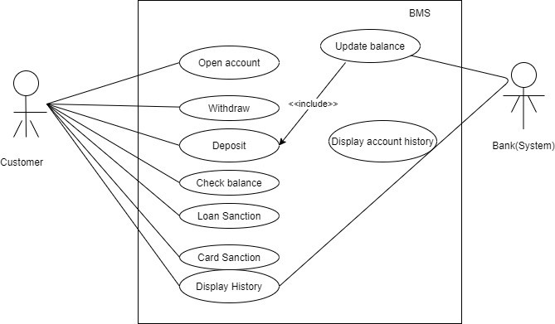

Class Diagram for Bank Management system:

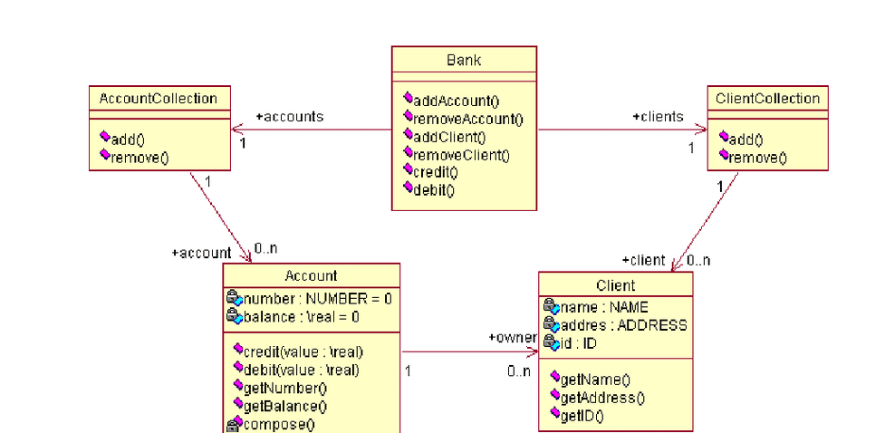

Activity flow diagram for Bank Management System:

